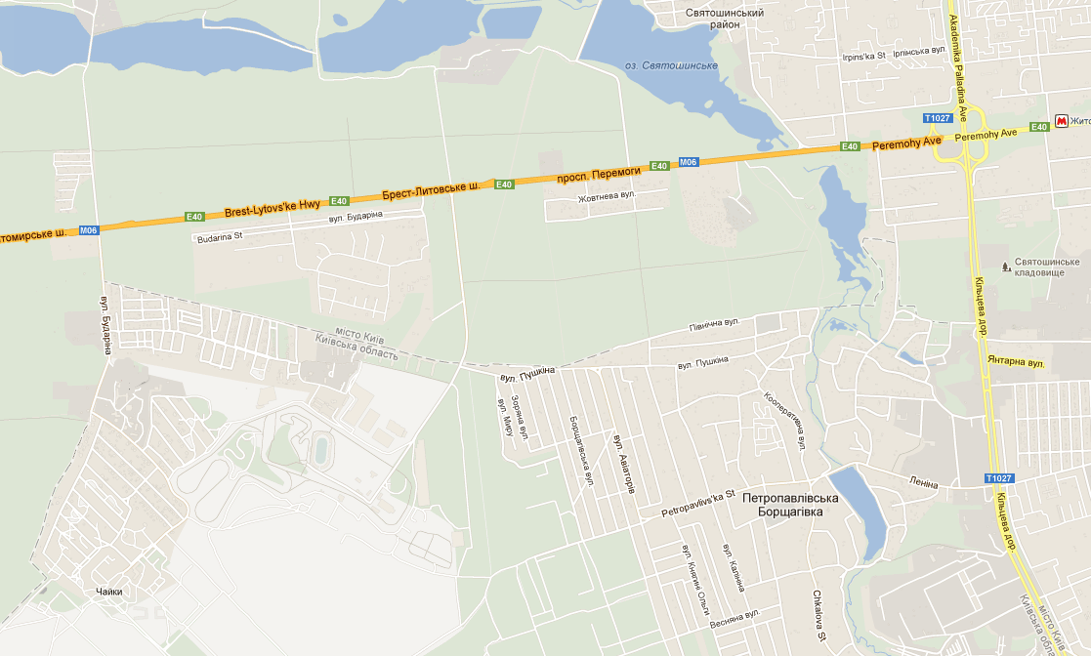

Kuehne+Nagel Ukraine
1, Dachnaya str.
Chaiky, Kyiv region

