**How to Upload Multiple Part Numbers**

**and Quantities to the Shopping Cart**

Go to Shopping Cart

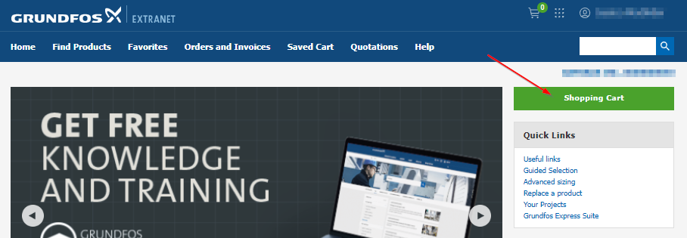

Go to ‘Add multiple products’.

Enter product number, enter a space and then enter quantity.

Hit enter and then enter product number, enter a space and then enter quantity.

You can add as many products as you like as long as they have one line each.

Example:

99917941 1

96525458 3

96416597 4

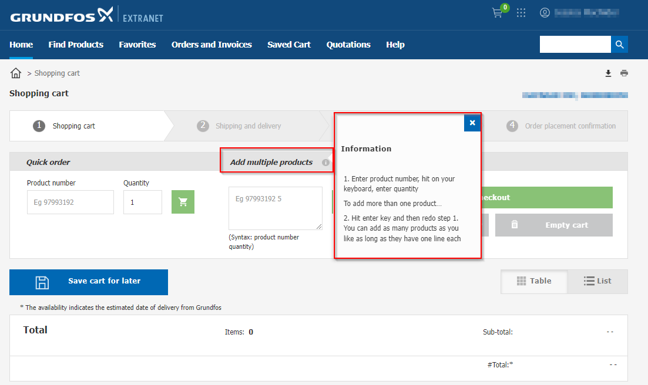

Or copy from Excel and paste into the multiple products field

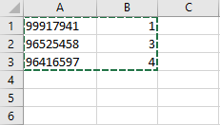 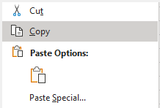

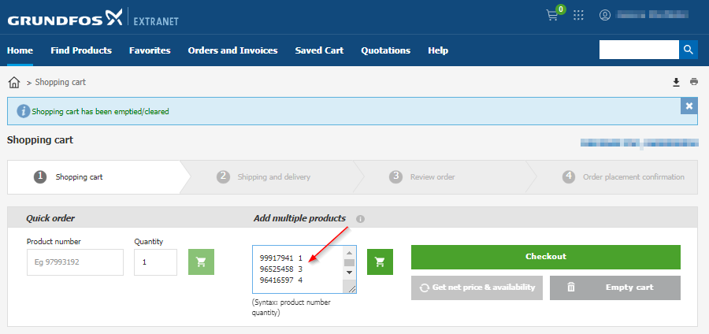

Once all product has been entered, click the cart

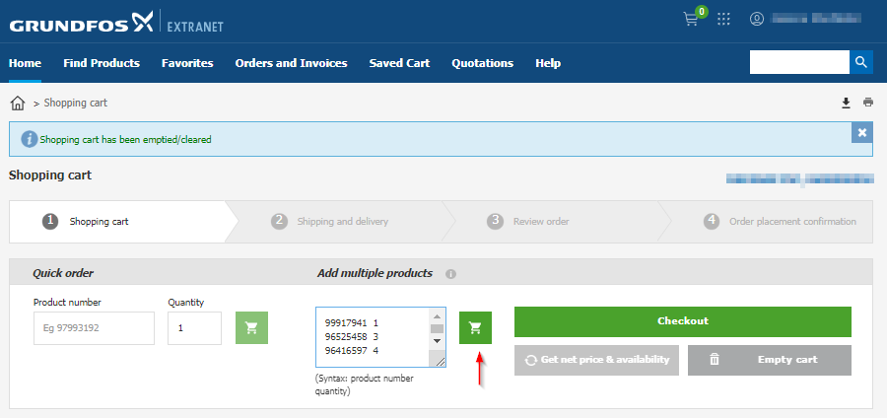

Part numbers and quantities will appear in cart; Click ‘Get net price & availability’

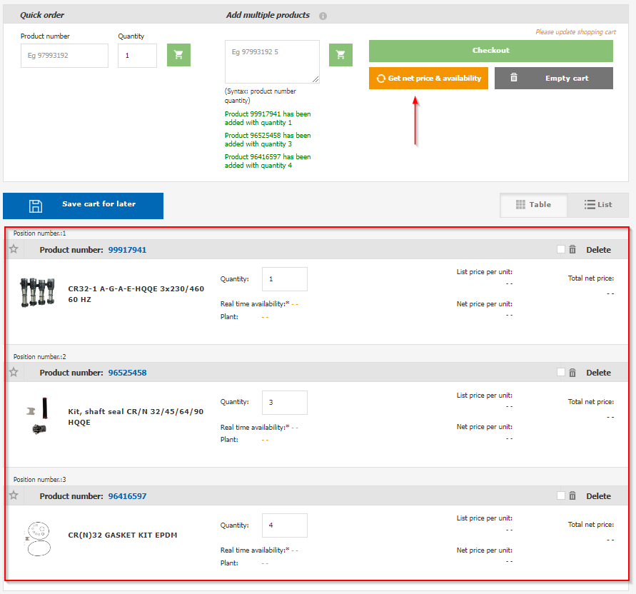

Pricing and Availability will appear; Proceed to Checkout as normal.

