**How to add part number to Favorites**

**and include user's product number**

Please note:

The information entered into the Favorites tab is only applicable to you, the user.

So if every user for a specific account # wanted this information in their Favorites tab, every user would have to add this information to their Favorites tab.

Also whatever information the user uploads, it is the responsibility of the user to maintain their product numbers.

Go to Favorites tab:

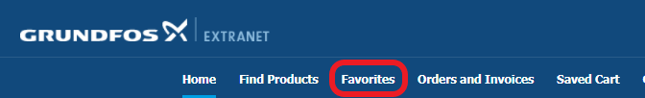

You should see a screen like this:

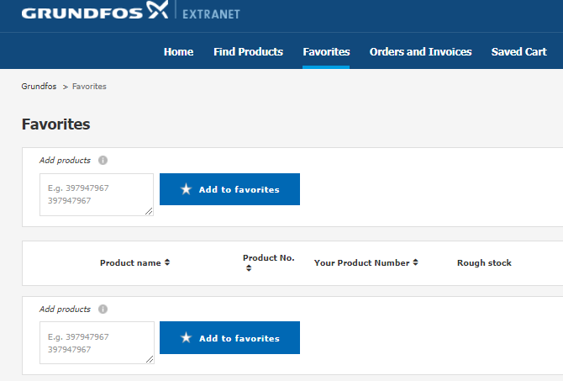

Enter the Grundfos part number and then click Add to favorites.

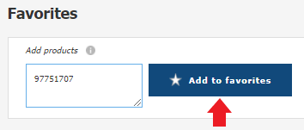

Enter your product number and click the blue check mark.

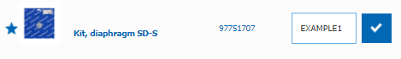

You should see the following message pop up:

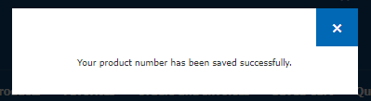

Now when this part number is purchased, you will see your product number next to the Grundfos part number in your Shopping cart and of course your product number will show in all relevant fields on related documents i.e. shipping document, order confirmation etc.

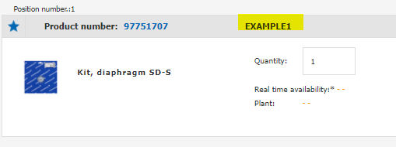

Please continue to next section to see how to add multiple part numbers into Favorites.

**How to add multiple part numbers to Favorites**

**and include user's product number**

If you have more than one part number to add to your Favorites you can enter a list of Grundfos part numbers and your product numbers in the Add products field with one click.

Create a list of Grundfos part numbers with your product numbers listed beside them.

This can be done in Excel, like this:

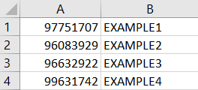

Or you could just create this in any text document i.e. Word, Notepad etc, just make sure there is a space between the Grundfos part number and your product number.

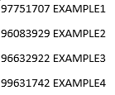

You can list as many part numbers as needed.

Copy your list of part numbers and paste into the Add products field: Click Add to favorites

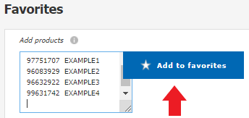

You should now see your list uploaded and displayed like this:

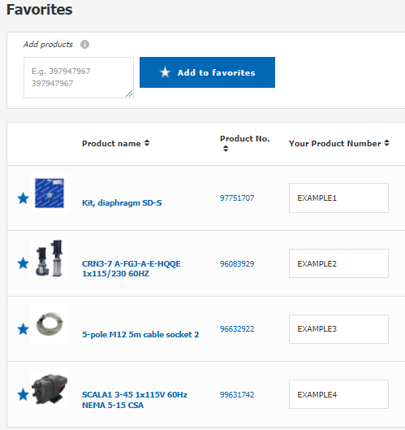

If you need to change your product number, simply edit within your Favorites tab and click the blue check mark.

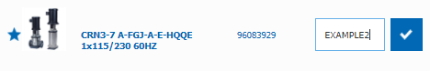

If you want to remove a product from your Favorites click the blue star.

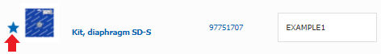

You should see the following message:

Click, Yes, remove and product will be removed from your Favorites list.

