Grundfos Warranty Programs

Supplement

Jennifer Dailey
8 August 2025
Overview
This is a supplement to the standard Terms and Conditions (T&C) that will explain more behind the various programs.

Section 1: General Information
- Purpose/Objective
- Definitions

Section 2: Guidelines
- Date Code (P.Code) Calculation
- Grundfos Product
- PACO Product
- Warranty Return Products (not allowed as Field Warranty Credits)
- Online Only Submissions (FWC and Delegated)
- In Lieu of Credit
- Non-Returnable Products (Field Warranty Claims)
- Non-Returnable (Field Warranty) Claim Guidelines
- Non-Returnable (Field Warranty) Claim Information Required

Section 3: Extended Warranty
- FWC: Performance Plus for SQFlex (PPP)
- FWC: WaterPRO program (qualified distributor only)
- SPE System 5-year Warranty
- Extended Warranty - Paid
- Municipal 5 year

Section 4: 3rd Party Warranty (Non-Grundfos Manufactured Products)
- WEG Warranty Policy
- Out-of Warranty Motors OR those not deemed as a warranty
- In-Warranty Procedure (Grundfos Customers)
- Baldor Warranty
- In-Warranty Procedure
- Out-of Warranty Motors OR those not deemed as a warranty
- Baldor Motor Nameplate
Jennifer Dailey
August 8. 2025

[Pick the date]

Section 1: General Information

Purpose/Objective

The information in this document has been compiled to address most questions regarding the warranty claims process and what forms to submit with claim. It contains forms & sets expectations when a failure arises. Every effort has been made to assure the information contained in this handbook is accurate. However, Grundfos reserves the right to make changes, or additions without prior notification to the field.

Definitions

- Grundfos Warranty Returns (RMA) – These are products determined by Grundfos to be returned to the nearest Service Center.

- Grundfos On-line Only Returns - These are products determined by Grundfos to be submitted directly online without a return. Please note that nameplate or further documentation may be required to be able to process.

  - Field Warranty Credits (FWC) – These are submitted via the FWC Cognito Form and are referred to as Field Warrantable Products, Field Warranty Claims, and FWC.
  - Delegated Warranty – These are submitted directly online by select customers.

- Grundfos Products – Grundfos, PACO, Yeomans, Chicago Pump, Morris, Sewer Chewer

- Grundfos Warranty Email – Service-US@servicesupport.grundfos.com

- Non-Potable - is water that is not of drinking water quality, but which may still be used for many other purposes, depending on its quality

- Partner - Refers to Grundfos distributor/channel partner, OEM purchaser and packager with an active account with Grundfos.

- Potable – A water fit for drinking, being free from contamination and not containing enough saline material to be regarded as a mineral water.

- Service Parts – these are parts and kits that are required to maintain and/or repair them.

- Vendors – these are Grundfos supply partners.
- Warranty Period (Period) – determines how long Grundfos pump will be considered under warranty

Section 2: Guidelines

- All warranty claims must be submitted within 30 days of the last labor date to complete the warranty repair.
- The parts replaced during a warranty repair will be maintained by the repairing facility for a minimum of 90 days after claims submitted.
- Reference Grundfos Standard Terms and Conditions of Sale
- Reference Grundfos Limited Warranty Terms
- P. Code: Original Production Date (See limited warranty specified in product I&O)
- Install/Failure dates (See limited warranty specified in product I&O)
- Installation and operating requirements must be satisfied as specified in product I&O
- Consider warranty on pump end and motor end separately
- Reference Franklin Electric Warranty Processing Procedures
  - FE8” Industrial Use submersible motors (non-water supply - BM applications only)
- Request for warranty service must be submitted as soon any claim defect is noticed
- Start-up Form must be provided
- Long term storage
  - Any product kept in long term storage will require a Grundfos Commission
  - This paid service will be used to reactivate the warranty period
- Required Certificates/Forms:
  - Non-Potable / Drinking (Dosing and Disinfection, Wastewater Pumps, etc.)
    - Certificate of Cleanliness Required (COC form completed)
      - Charge may be applied for Cleaning
  - Products exposed to toxic materials or any mining applications
    - Certificate of Cleanliness Required (COC form completed)
    - Decontamination Form Required
    - MSDS/SDS Required
      - Charge for all activities, Decline and either Return Product or Dispose
  - Products exposed/Installed in Radioactive applications can NOT be returned

Date Code (P.Code) Calculation

Grundfos Product
Grundfos box products contain a date code or production code on the name plate of our pumps and Motors. Warranty Period: 24/30 (24 months from installation, not to exceed 30 months from Date code)
Date code (ex: 1708 = 2017, 8th week) + 2 years (1908) + 26 additional weeks (1934)
The warranty period would expire on the 34th week of 2019.

PACO Product
- Based off the shipped date of the product to the customer from our Grundfos facility.


Warranty Return Products (not allowed as Field Warranty Credits)

Specific products that must be returned will be specified on the Quick Warranty Guide.
This guide will direct you on those products that need to be returned for inspection vs. not returned.

- Ship to the nearest Grundfos Service Center or Authorized Service Partner (ASP) for warranty consideration.
  - RMA required when returning to Grundfos: Provide pertinent information
- Products exposed to Non-Potable materials must have the following documentation
  - Certificate of Cleanliness (COC) form
  - If not provided, an extra cleaning cost may occur
- Products exposed to toxic materials must have the following documentation
  - MSDS/SDS & completed
  - Certificate of Cleanliness (COC) form
- Products exposed/installed in radioactive applications cannot be returned

Online Only Submissions (FWC and Delegated)

FWC: Partner must maintain the product for 90 days (Grundfos reserves the right to audit)
Delegated: Partner must maintain the product for 7 days (Grundfos reserves the right to audit)

Optional: If you would still like to get an inspection report, you can return to nearest Grundfos Service Center or Authorized Service Partner (ASP) using the standard RMA Process.

In Lieu of Credit
  - Repair
  - Replace

Non-Returnable Products (Field Warranty Claims)

Specific products that must be returned will be specified on the Quick Warranty Guide.
This guide will direct you on those products that need to be returned for inspection vs. not returned.

Non-Returnable (Field Warranty) Claim Guidelines
  - Use Grundfos Field Warranty e-form on the Grundfos Extranet
  - Warranty for manufacturing defects may be determined by our Representatives and Distributors
  - Provide all required information on the e-form according to instructions (see link on e-form)
  - 4” SP under 10HP - Do not separate Grundfos MS402/MS4000 motor-equipped pumps in the event the complete pump is claimed for warranty (use complete part number from price book). For 4” SP failures where only the pump end or only the motor failed – list only the failing product number (use individual pump end or motor part number from price book).
  - Do not separate SQ/SQE/SQE-NE/SQFlex, BMQE pumps
  - Incorrect or insufficient information will delay processing or risk rejection of claim
  - Field warranted/field scrapped products must be properly disposed to ensure against possible reuse or environmental hazard

Non-Returnable (Field Warranty) Claim Information Required
  - Distributor Information (Account name & number, contact name, email address, contact phone, partner reference number)
  - Material/Product number (note: ten products, maximum, allowed per form)
  - Original production date code (P. Code)
  - Failure Reason: Detailed description of the primary fault (reason the product failed)

Section 3: Extended Warranty

FWC: Performance Plus for SQFlex (PPP)

- Performance Plus Policy - For Grundfos SQFlex and controls only.
- For extended warranty claims only: (i.e.: the product is older than 30 months from date of manufacture or the failure mode is outside our standard coverage but within our extended warranty terms). Provide the Performance Plus number and attach a photocopy of the Performance Plus policy and purchase date.
- For standard warranty claims: do not provide the Performance Plus number on the e-form even if a PPP is presented
- For SQFlex (Special purchased insurance policy)
  - Product must be installed in accordance with the I&O by a qualified installer using a proper lightning arrestor
  - Policy must be purchased and completed at the time of pump sale and installation
    - Material number: LSQSL020
    - Coverage is limited to the original owner and is good for five (5) years from date of original installation
  - Additional coverage provided:
    - Lightning/Line surges
    - Normal sand wear
    - Dry running
    - The Grundfos SQFlex or controls will be repaired or replaced regardless of occurrence for the life of the policy.
    - Labor/pulling charges are not included
  - Reference PPP and Consumer Information Brochure for further qualifications

FWC: WaterPRO program (qualified distributor only)

- WaterPRO program is an extension of the Standard Warranty for manufacturing defects and does not cover items noted as additional coverage in the PPP purchased insurance program
- The products are eligible when installed by a Grundfos WaterPRO Dealer in a residential water well application:
  - 4” SP pump ends and complete units (up to 5 HP), 3” SQ and SQE pumps, SA-SPM5, CU301, and CU331SP pump controls.
- Qualifying products are eligible for 60 months from installation, but no more than 66 months from date of manufacture.
- Should the pump fail due to any of the conditions specified under the Grundfos Pumps limited warranty prior to the expiration of the 5-year term (60 months from installation, but no more than 66 months from date of manufacture), the end-user should contact their Grundfos WaterPRO Dealer.
- Grundfos WaterPRO warranty does not cover labor charges involved in pulling and reinstalling the pump.

SPE System 5-year Warranty
Location: I&O Manual
Owners: Steven Doggett, Eric Schriefer

- Standard Warranty Applies
- 5-Year Warranty applies only when:
  - Installation Form is completed and sent with Warranty Submission
  - System includes CUE drive and Sine Wave Filter
  - MS6000P Motor
- Submissions must include evidence of the above.
  - If not, then contact Sales to work with the customer or reject and advise customer of requirements

- FAQ: https://grundfos.service-now.com/gsk?id=kb_article_view&sysparm_article=KB0033138

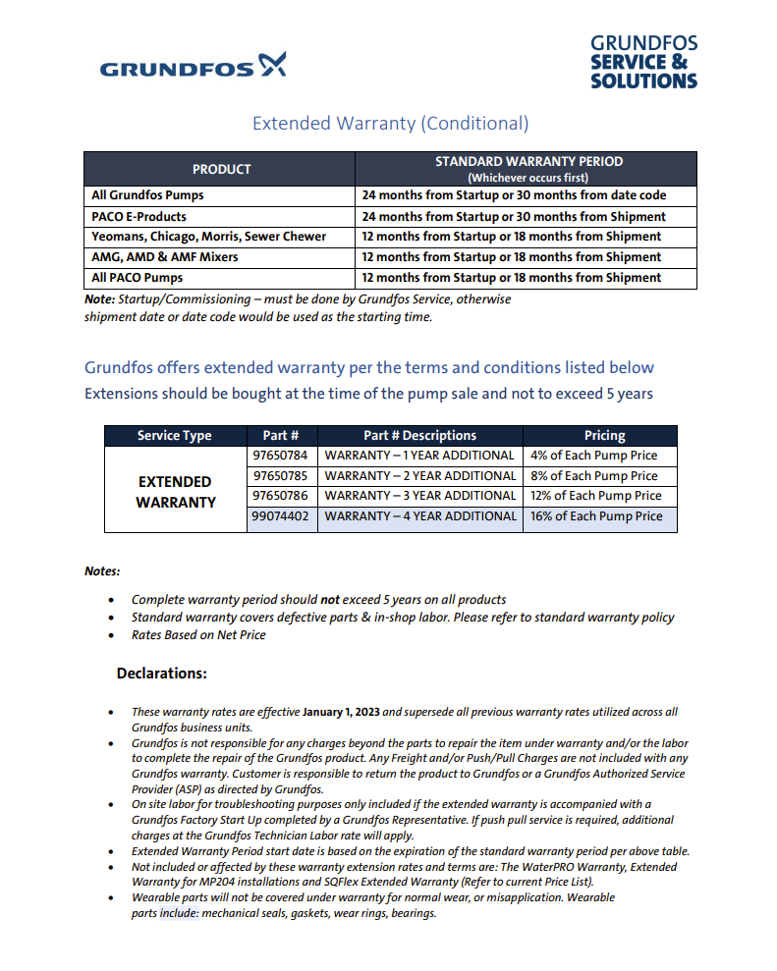
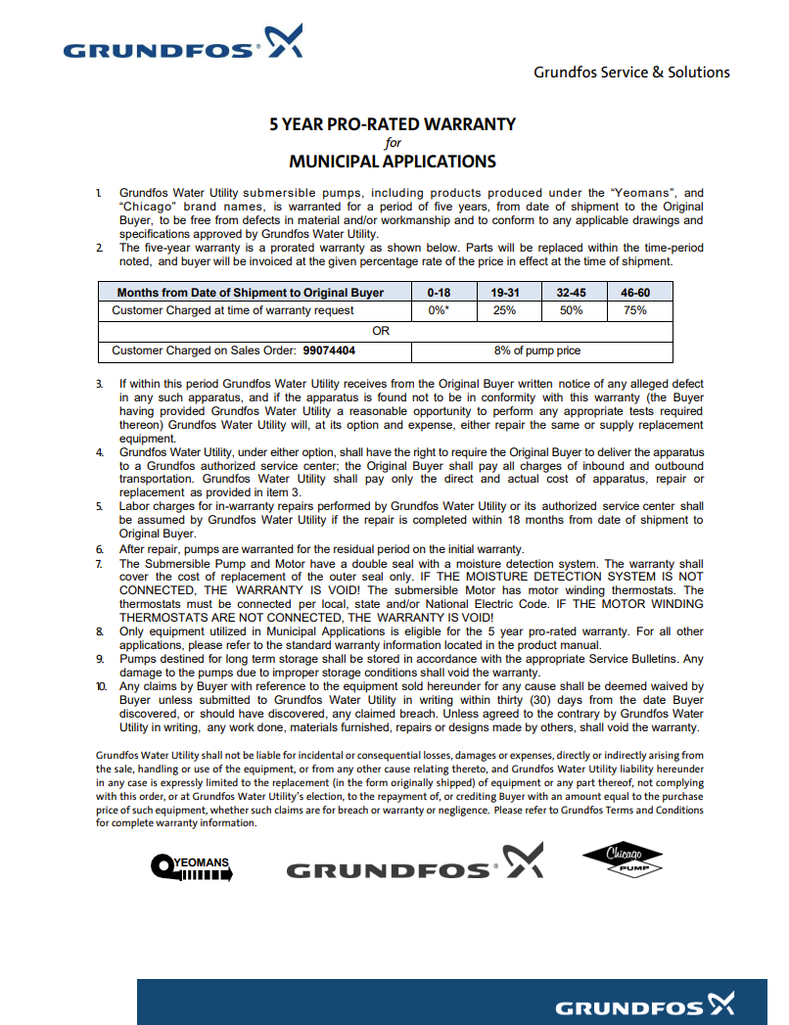

Section 4: 3rd Party Warranty (Non-Grundfos Manufactured Products)

For all 3rd Party warranty claims, customers should first contact the Grundfos Service Department to open a notification for tracking purposes. The 3rd Party Vendor will determine whether the product should be repaired or replaced, and Grundfos will coordinate all communication with the 3rd Party and the customer.

Wessels Tank Warranty

Request warranty claim via the Extranet RMA claim form. https://www.cognitoforms.com/Grundfos1/GrundfosOnline

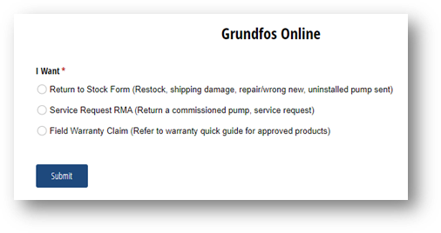
Within the request form, you will be asked if this is for a tank, select yes and complete the required information:

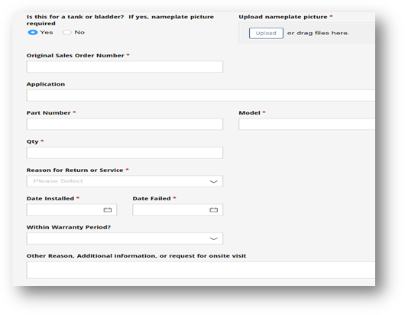

The Grundfos Service team is committed to facilitating seamless communication between you and our third-party vendor, Wessels. Upon receiving your information, we will coordinate with Wessels to expedite the process and ensure that you receive the return RMA promptly.

Once you (the customer) have shipped the return tank to Wessels, they will inspect the pump and provide a warranty determination to Grundfos. At that time, Grundfos will issue the credit/replacement.

End to end turnaround time approx. 5-7 business days once received back at Wessels.

Information required for Wessels:
- Picture or the nameplate(s)
- Date of failure
- Detailed description of failure or issue
- Maximum operating temp & Pressure of system
- Minimum system pressure at the tank (PSI)
Wessel’s Terms:
- 1 year warranty
- Any shipment without approved Wessels RMA paperwork or Wessels RMA # will be refused.
- If water needs to be removed from a tank use the drain plug. If there is no drain plug drill hole in BOTTOM HEAD ONLY. If a hole is drilled in the shell the RMA can be refused.

WEG Warranty Policy
Find nearest WEG Authorized canters at https://www.weg.net/institutional/US/en/contact/service-network
          - Terms:
    - 24/30 = 24 months from date of installation, but not more than 30 months from
date of manufacture (excludes washdown motors which are 12/24).
IEEE 841 motors have 60 month warranty from date of invoice

Out-of Warranty Motors OR those not deemed as a warranty
- Must be by WEG, WEG Authorized Service Center (WASC) or EASA shop
  - The customer will pay the WASC or EASA shop for inspection and repair services
- If motor was returned to Grundfos via an RMA request or to a Grundfos ASP
  - The customer pays Grundfos or Grundfos ASP.
  - Grundfos will pay for the inspection at the WASC or EASA shop

In-Warranty Procedure (Grundfos Customers)

Motors frame size 215 and smaller (10 Hp and smaller).
- Take clear photo of nameplate (date code and serial number).
- Provide to Grundfos Distributor with reason for failure.
- Distributor submits an Extranet claim to Grundfos providing clear nameplate photo with submission
- Grundfos completes No Fault claim form and submits to Warranty@weg.net.
  - If requesting a replacement, then email to Nathan Sublett nsublett@weg.net.
  - Grundfos provides ship to instructions for replacement.

Please Note: No Fault Motors can be scrapped locally after case is completed.
No Fault Excludes Washdown and IEEE 841 motors which must be inspected by a WEG Authorized Service Center(WASC) or if none is available, an EASA affiliated service shop.

Motors above 215 frame (larger than 10 Hp)
- Must be inspected by WEG Authorized Service Center WEG ASC (WASC) or EASA shop.
- Distributor contacts motor centers directly (WEG Authorized centers link)
- The WASC or EASA provides support by contacting
  - Grundfos at Service-US@sales.grundfos.com
  - Nathan Sublett of WEG service at nsublett@weg.net in advance of commencing work.
- When WEG approves after review of inspection report, nameplate photo, and failure photos then WEG directs WASC or EASA shop to:

A. Repair if practical
B. Scrap if not practical
• WEG ASC or EASA shop will invoice WEG for the inspection or repair work
• Customer should not pay the WEG ASC or EASA shop

Note: WEG might request a WASC or EASA shop to return a motor for quality review, this will be between WEG and the motor shop and will not delay the warranty replacement or credit.

Baldor Warranty

In-Warranty Procedure

All Baldor Motors

Find nearest center at http://www.baldor.com/resources-and-support/customer-support/service-centers
  - Terms:
    - 24 months from date of installation, but not more than 30 months from date of manufacture
    - Super-E premium efficient motors: 36 months from date of manufacture
  - See below for date coding (S/N) system
  - Report needed from Baldor Center (ASC)

Out-of-Warranty Baldor Motors OR those not deemed as a warranty

- Must be by Baldor Authorized Service Center (BASC)
  - The customer will pay the BASC shop for inspection and repair services
- If motor was returned to Grundfos via an RMA request or to a Grundfos ASP
  - The customer pays Grundfos or Grundfos ASP.
  - Grundfos will pay for the inspection to the BASC

Baldor Motor Nameplate

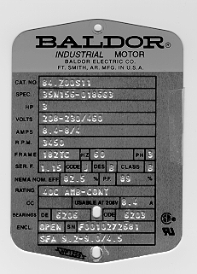

How to read the new Baldor motor serial number
(Date Code)

Above example: F 00 10 27 2681

F = Plant
00 = Year
10 = Month
27 = Day of the Month
2681 = Production Sequence Number

